Vehicle Access to University Sports Ground/Kenworthy Woods

Please follow the indicated route for access to the Sports Ground. There is no access to the Sports Ground from Junction 5 of the M60. If you are using the M60 to get to the venue then you will need to exit either by Junction 4 or 6 and make your way to Sale Road. Sat Nav – M23 0DU for Jcn Yew Tree Lane and Willenhall Road

There will be NO PARKING permitted on the approach road to the venue or on Willenhall Road.

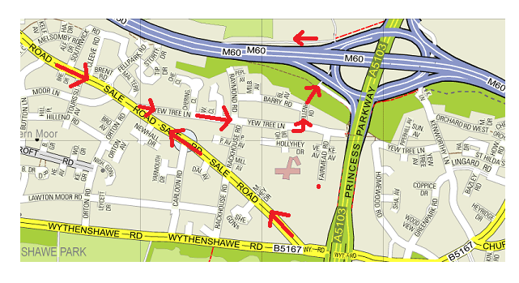

Pedestrian Access to University Sports Ground/Kenworthy Woods

