http://mbpfilia1cz.blox.pl/resource/8673546462_73b2df8cb3_b.jpghttp://mbpfilia1cz.blox.pl/resource/8673546462_73b2df8cb3_b.jpghttp://mbpfilia1cz.blox.pl/resource/8673546462_73b2df8cb3_b.jpghttp://mbpfilia1cz.blox.pl/resource/8673546462_73b2df8cb3_b.jpghttp://mbpfilia1cz.blox.pl/resource/8673546462_73b2df8cb3_b.jpghttp://mbpfilia1cz.blox.pl/resource/8673546462_73b2df8cb3_b.jpghttp://mbpfilia1cz.blox.pl/resource/8673546462_73b2df8cb3_b.jpghttp://mbpfilia1cz.blox.pl/resource/8673546462_73b2df8cb3_b.jpghttp://mbpfilia1cz.blox.pl/resource/8673546462_73b2df8cb3_b.jpghttp://mbpfilia1cz.blox.pl/resource/8673546462_73b2df8cb3_b.jpghttp://mbpfilia1cz.blox.pl/resource/8673546462_73b2df8cb3_b.jpghttp://mbpfilia1cz.blox.pl/resource/8673546462_73b2df8cb3_b.jpghttp://mbpfilia1cz.blox.pl/resource/8673546462_73b2df8cb3_b.jpg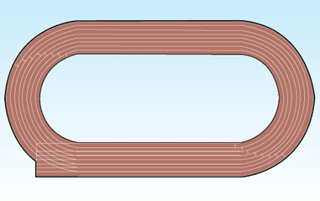http://mbpfilia1cz.blox.pl/resource/8673546462_73b2df8cb3_b.jpghttp://mbpfilia1cz.blox.pl/resource/8673546462_73b2df8cb3_b.jpghttp://topfemaletennisplayers.com/wp-content/uploads/2013/08/tennis-court.jpghttp://topfemaletennisplayers.com/wp-content/uploads/2013/08/tennis-court.jpghttp://topfemaletennisplayers.com/wp-content/uploads/2013/08/tennis-court.jpghttp://topfemaletennisplayers.com/wp-content/uploads/2013/08/tennis-court.jpg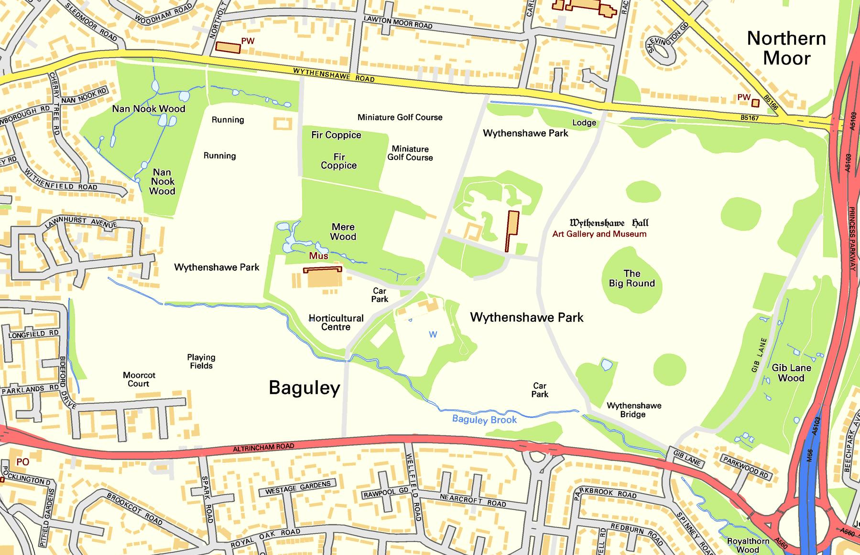

U20’s and Seniors only

10

H

I

F

J

G

**Baseball Pitches**

**Out of bounds to Runners and Spectators**

 Marshal Point

 Club Tent Area

|  |  |  |  |
| --- | --- | --- | --- |
| Time | Event | Approx Dist | Course |
| 12:15pm | U13G + U13B | 3200m | A B C D E F G H J -> Finish |
| 12:30pm | U15G + U15B | 45000m | A B C D -> F J -> B C D E F G H J - > Finish |
| 12:50pm | U17G + U17B | 6100m | A B C D E F G H J- > B C D E F G H J -> Finish |
| 13:30pm | Sen, U20 +  Vet Women | 7800m | A B C D -> F J -> B C D E F G H I J - > B C D E F G H I J -> Finish |
| 14:30pm | Sen, U20 + Vet Men | 9700m | A B C D E F G H I J -> B C D E F G H I J –> B C D E F G H I J-> Finish |

Toilets

Car Parking

Cut off U15’s & U20’s and Sen Women

**First Lap**

E

D

First Aid

Registration

C

A

Start

Finish

B

**Manchester Area Cross Country League**

**– Wythenshawe Park**

**No entries taken on the day at this event (incl Guests)**

**Please check entry lists on website before travelling to event (www.maccl.co.uk)**

Car Park

Courtyard Cafe